Igus Lead Screw

Drylin High Helix Lead Screw
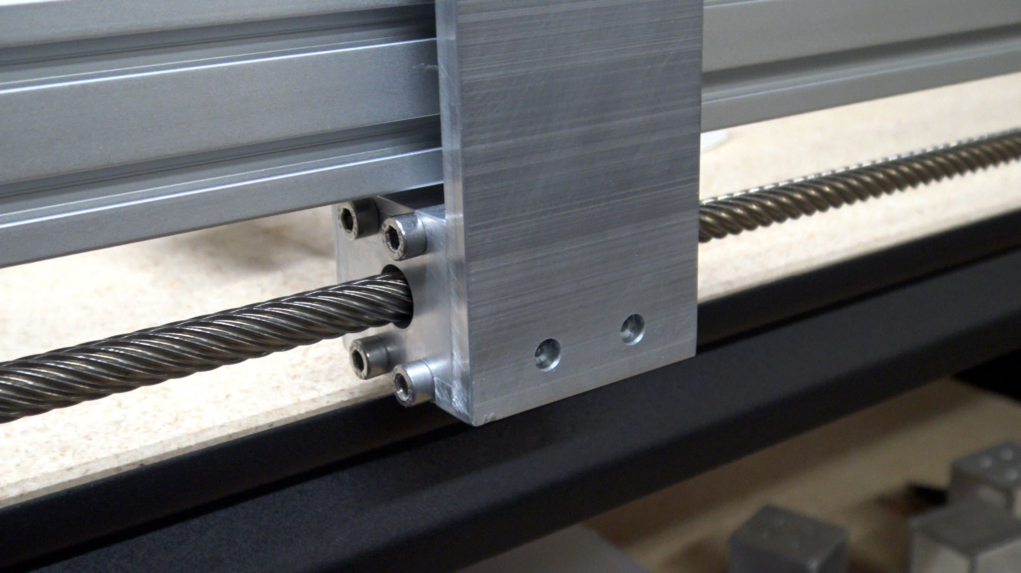
Part List
Igus 761mm Long (X Axis) | $ 93.23 | DST-LS-10x50-R | DST-LS-10X50-R-ES
Igus 485mm Long (Y Axis) | $ 74.80 | DST-LS-10x50-R | DST-LS-10X50-R-ES
Igus Lead Screw Nuts | $ 35.78 | DST-JFRM-2525DS10X50 | Ds10x50
12mm T12x2 Trapezoidal ACME Lead Screw w/ Brass Nut

Drylin High Helix Lead Screw Nuts
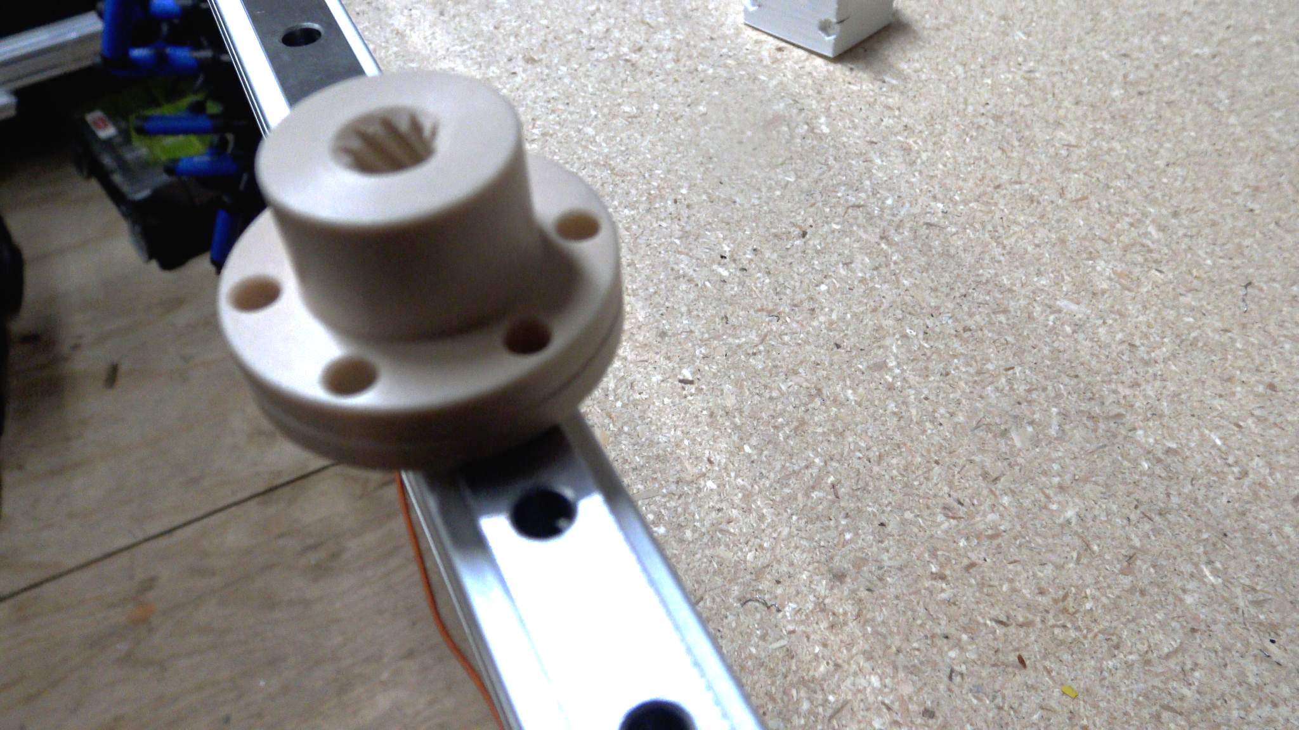

Igus Lead Screw Nuts | $ 35.78 | DST-JFRM-2525DS10X50 | Ds10x50

Related Content
WorkHorse BOM
Igus Lead Screw
Linear Rails
WorkHorse Frame
WorkHorse Motors
WorkHorse Printer: Users Guide
Duet Wifi Setup
Duet 2 vs Duet 3
WorkHorse 3D Printer
Recommended Print Settings
3D Distributed

Firmware Files
config.g
Homeall.g
homex.g
Homey.g
Homez.g

Duet 3 Mainboard Setup
Duet3D YAT Commands
Reverse Motor Direction

Duet Wifi
Duet Wifi Setup

